# Part 3

To enter into Hive, enter this command in terminal:

Hive

To retrieve data from Hive table, enter this command in terminal:

SELECT * FROM mbb;

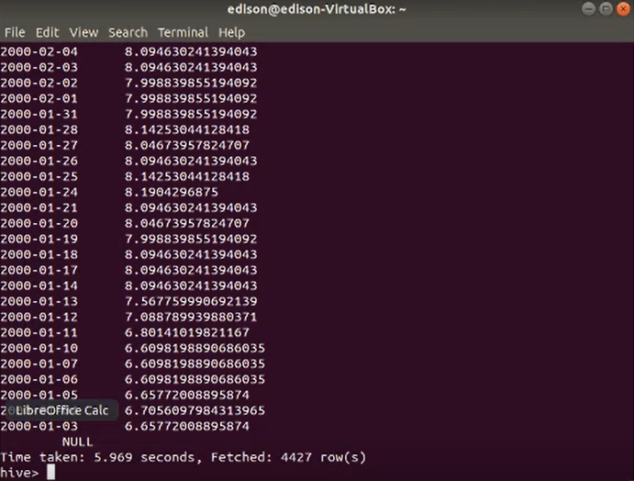

In Python, use following command to read data from mbb table in Hive and store them into DFStock2 dataframe.  
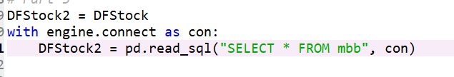

Using describe function,



The data retrieved from Hive consists of 2 columns (date and close columns) with 4425 observations:

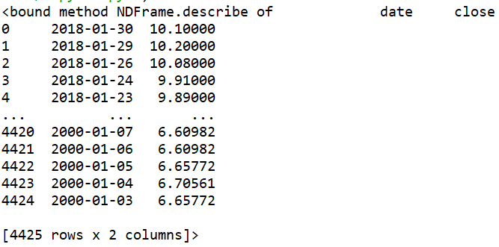

Use dtypes function to check the data type of columns in dataframe:



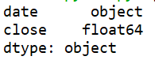

Use isnull function to check for null values and use sum function to calculate total count of null value:



There is no null value in the data:

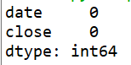

Since there is no null value and the data are in correct data type, there is no data cleaning needed.